Lecture Notes

Math E-10

April 2, 2014

Nick Gallimore

A person riding a ferris wheel that makes a complete revolution after 8 minutes height is represented by *h(t)* where t is the persons current height in feet.

Diameter = 40ft

1 turn in 8 minutes.



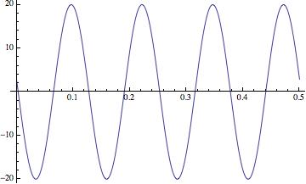

Graph a function f(theta) representing the y-coordinate of a point in the unit circle

Identities of trig functions

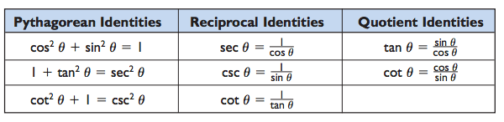

omega = {{2 \pi} \over T} = {2 \pi f} , 

In a rotating or orbiting object, there is a relation between distance from the axis, [tangential speed](http://en.wikipedia.org/wiki/Tangential_speed), and the angular frequency of the rotation:

omega = v/r

